NEX0S A1
Team Members

Name | ID
Fady Basem | 245027
Sama Zeitoun | 245040
Asmaa Mohamed | 245610
Kirolos Ashraf | 245402
Sayed Emam | 245412

Supervisor TA
Eng.AhmedKhattb
- Introduction
The NEX0S A1 platform is developed to bridge the gap between human creativity and technical execution. Traditional software development is often hindered by high costs, long timelines, and technical complexity. NEX0S A1 addresses these needs by providing an autonomous, AI-driven environment where software is synthesized directly from natural language. The system functions as a digital orchestrator, integrating with cloud providers and advanced LLMs to transform business objectives into secure, live applications. Strategically, this system aligns with the goal of democratizing technology, enabling rapid digital transformation for entrepreneurs without the need for manual coding expertise
  - Purpose
The purpose of this SRS is to provide a complete technical and functional specification for NEX0S A1. It defines the system's requirements, design constraints, and operational logic to ensure a unified development and deployment process
  - Scope
The scope of NEX0S A1 covers the entire software lifecycle: from natural language requirement gathering and full-stack code synthesis (Frontend/Backend/DB) to automated security auditing (OWASP compliance) and autonomous cloud hosting
  - Definitions
- AI: Artificial Intelligence
- SRS: Software Requirements Specification.
- SAST: Static Application Security Testing.
- Full-Stack: Complete application development (UI + Server + DB).
- Self-Healing: System's ability to fix runtime errors autonomously
  - Overview
This diagram represents the highest level of abstraction for the NEX0S A1 System. It defines the system boundary and illustrates the high-level data exchange between the core platform and its four primary external entities: the Client, Cloud Provider, AI Engine, and Security Standards

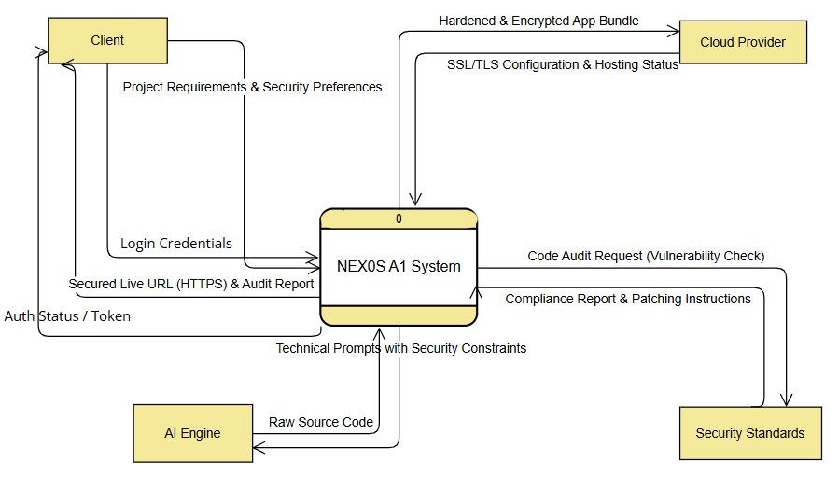
- Overall Description

  - System perspective
NEX0S A1 is a standalone, independent product that acts as a service layer. It interfaces with Cloud Hosting APIs for deployment and utilizes LLM APIs for code synthesis
  - User classes
- Client (General User): Non-technical individuals requiring a conversational interface
- AI Brain: Technical users monitoring AI performance and system log
  - Operating environment
- Client: OS-agnostic web browsers (Chrome, Firefox, Safari).
- Server: Ubuntu 22.04 LTS , AI modules , Node.js backend.
  - Assumptions & constraints
- Constraints: AI logic must be in Python; server logic in Node.js. High-performance GPUs (NVIDIA) are required.
- Assumptions: Stable internet for clients; availability of cloud hosting APIs
- User Requirements
The user wants to "build a website by just talking to a computer." They require a system that understands plain English/Arabic, writes the code, ensures it isn't hackable, and puts it online without requiring the user to touch a server or write a single line of syntax
- Functional Requirements
1. Functional Requirement Name: User Authentication & Secure Access
- Description/Action: The system validates user identity through encrypted credentials to grant access to the AI project workspace.
- Requirements/Inputs: User login credentials (Username/Email and Password).
- Source: Client (User).
- Pre-condition: User must have a registered account in the system database.
- Post-condition: A secure session is established, and a unique Auth Token is generated for the session.
- Output: Redirects the user to the "NEX0S Project Dashboard."
2. Functional Requirement Name: AI-Driven Project Consultation
- Description/Action: The AI Brain processes natural language input to define technical features, business logic, and project goals.
- Requirements/Inputs: Natural Language Project Description (Prompt).
- Source: Client (User).
- Pre-condition: User must be successfully authenticated and have an active session.
- Post-condition: A structured Technical Blueprint is generated and stored in the D1 Requirements Store.
- Output: Display of the "Technical Requirements Document" for user confirmation.
3. Functional Requirement Name: Autonomous Full-Stack Synthesis
- Description/Action: The AI engine concurrently generates the frontend code, backend logic, and database schemas based on the project blueprint.
- Requirements/Inputs: Approved Technical Blueprint from D1.
- Source: Internal System (D1 Requirements Store).
- Pre-condition: The user must explicitly approve the consultation results and trigger the build phase.
- Post-condition: Production-ready source code is synthesized and stored in the D2 Synthesis Repository.
- Output: Progress bar updates showing "Frontend/Backend/DB Generation Complete."
4. Functional Requirement Name: Intelligent Security Hardening
- Description/Action: The system performs a mandatory SAST scan to identify vulnerabilities and applies automated "Hardening" patches.
- Requirements/Inputs: Raw Source Code from D2.
- Source: Internal System (D2 Synthesis Repository).
- Pre-condition: The Synthesis phase must be successfully completed without errors.
- Post-condition: A secured version of the source code is stored in the D3 Secured Repository.
- Output: Security Audit Report highlighting fixed vulnerabilities and the "Zero-Risk" status.
5. Functional Requirement Name: Autonomous Cloud Deployment
- Description/Action: The system provisions cloud server resources and uploads the secured application to a live environment.
- Requirements/Inputs: Hardened Source Code from D3.
- Source: Internal System (D3 Secured Repository).
- Pre-condition: Code must pass the Security Hardening phase with a "Secure" certification.
- Post-condition: The application is successfully hosted and running on a cloud-native infrastructure.
- Output: Display of the "Final Live URL" to the user.

- Non-Functional Requirements
1. Performance: Response Latency and Throughput
- Description: The system must maintain high-speed interactions to ensure a fluid conversational experience and rapid project delivery.
- Metric: The AI consultation interface must respond to natural language queries in less than 2 seconds. Furthermore, the complete "End-to-End" synthesis process (from prompt to live URL) must not exceed 5 minutes for applications of standard complexity.
2. Reliability: System Availability and Self-Healing
- Description: As a cloud-native platform, NEX0S A1 must be consistently accessible to users and capable of maintaining live projects without manual intervention.
- Metric: The platform shall maintain an operational uptime of 99.9%. The "Self-Healing" module must successfully resolve at least 85% of common runtime server errors (e.g., 500 Internal Server Errors) autonomously.
3. Security: Authentication and Data Protection
- Description: Given that the system handles proprietary business logic and generates source code, robust security measures are mandatory at every layer.
- Metric: Access is restricted via Multi-Factor Authentication (MFA). All data at rest must be encrypted using AES-256 standards, and all data in transit between the AI Brain and the Cloud Provider must be secured via TLS 1.3.
4. Scalability: Resource Management and Concurrent Support
- Description: The architecture must be able to handle growth in the user base and the increasing resource demands of the AI code generation models.
- Metric: The system must support at least 1,000 concurrent users performing code synthesis or security scans simultaneously without a performance degradation exceeding 10%. The cloud infrastructure must support horizontal scaling to accommodate new hosted projects.
5. Usability: Zero-Code User Experience
- Description: The platform interface must be optimized for non-technical entrepreneurs, ensuring that the complexity of the AI logic is hidden behind an intuitive design.
- Metric: A first-time user with zero programming knowledge should be able to navigate from initial login to a live deployed website in no more than 5 logical steps within the dashboard.

- UML Diagrams

  - Use Case Digram
This diagram illustrates the high-level interactions between the two primary actors—the Client and the AI Brain—and the internal functional modules of the NEX0S A1 System. It defines the boundaries of the system and the specific goals (Use Cases) each actor achieves
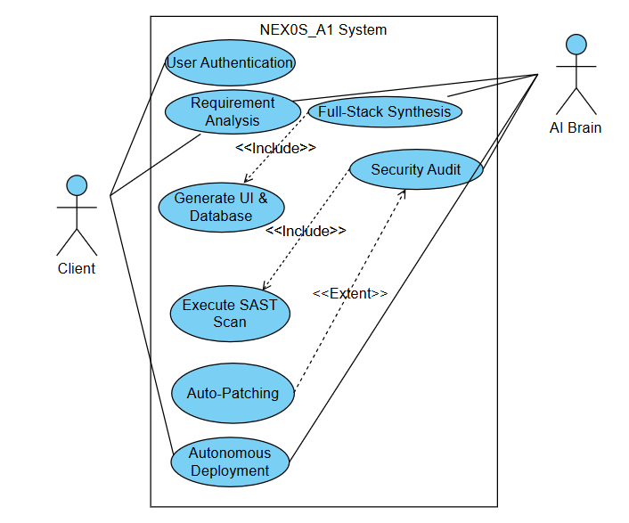

  - Use Case Digram User Authentication
This diagram provides a detailed view of the User Authentication process, focusing specifically on how the Client interacts with the system's security gate. It breaks down the authentication steps into specific sub-actions like submitting credentials and performing MFA challenges
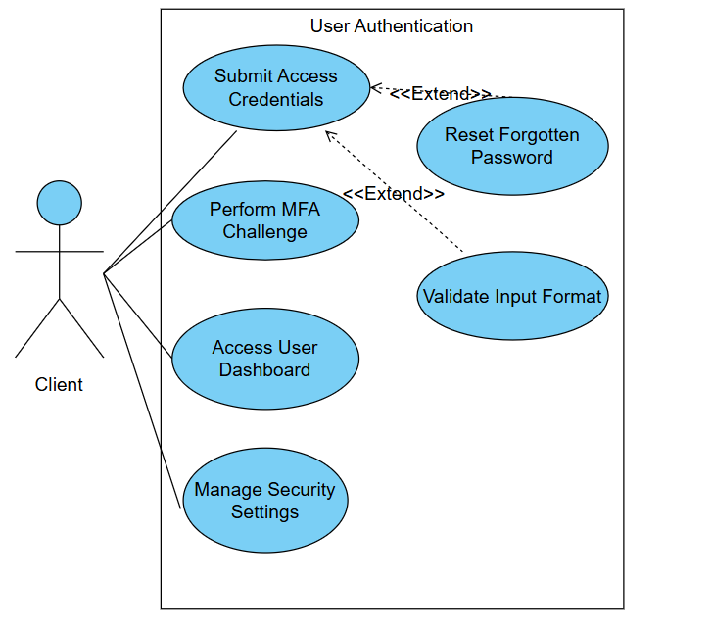
  - Use Case Digram Requirement Analysis
This diagram details the interaction between the Client and the AI Brain during the project definition phase. It focuses on how the system captures and structures the user's vision through the Start Consultation and Describe Project use cases
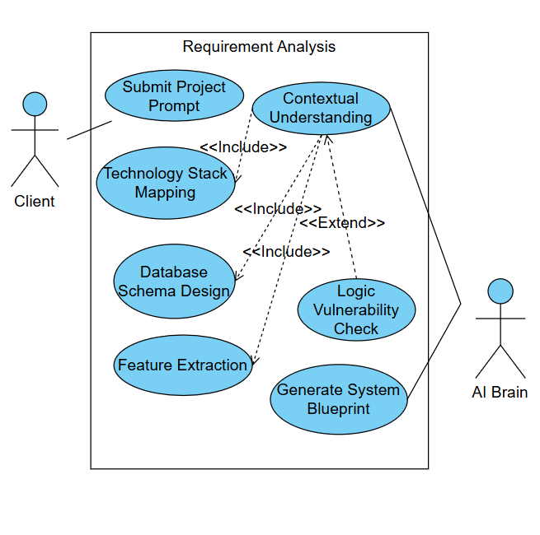
  - Use Case Digram Full-Stack Synthesis
This diagram illustrates the core technical operations of the AI Brain as it executes the Full-Stack Synthesis phase. It focuses on the internal automated processes triggered once the requirements are approved
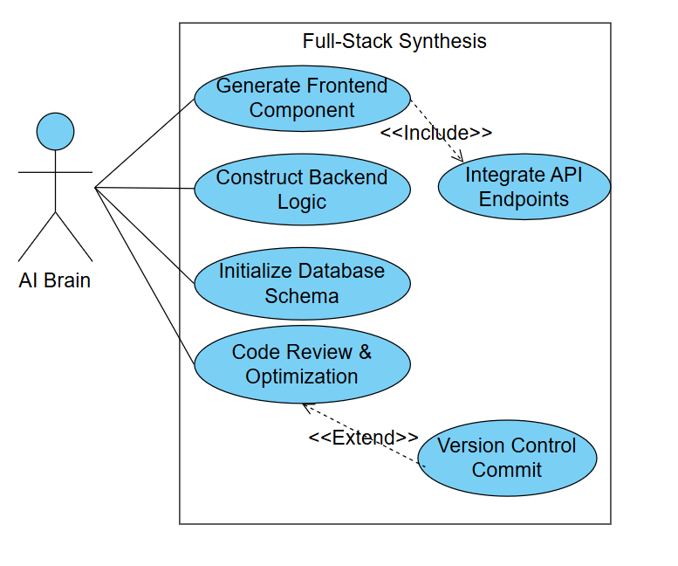
  - Use Case Digram Security Audit & Hardening
This diagram illustrates the autonomous security operations performed by the AI Brain to ensure the generated application is production-ready and resilient. It focuses on multi-layered security testing, including Static (SAST) and Dynamic (DAST) analysis, as well as dependency vulnerability checks
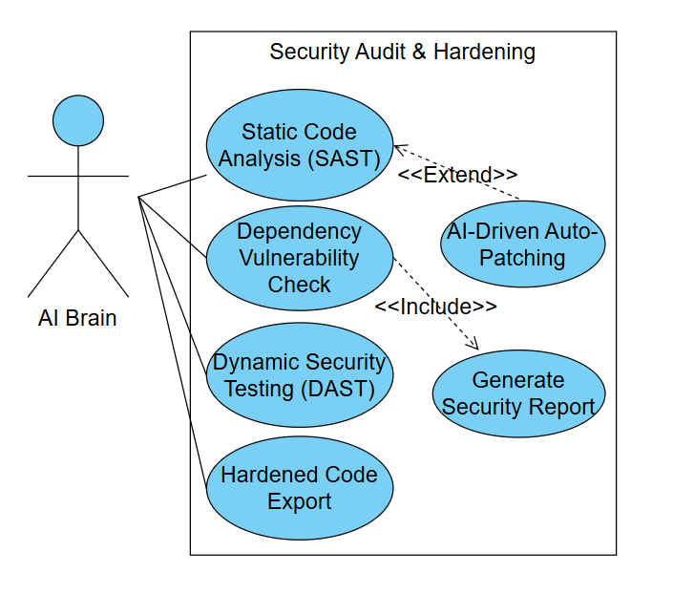
  - Use Case Digram Autonomous Deployment
This diagram outlines the final operational phase where the AI Brain manages the transition of the hardened code to a live production environment. It details the automated infrastructure tasks required to host the user's application on the cloud
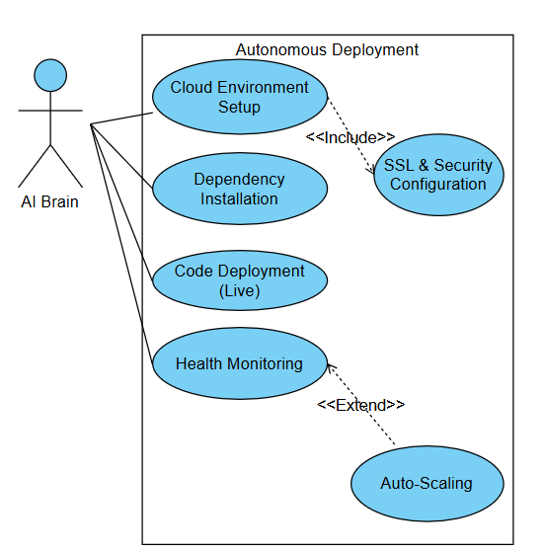

  - Sequence Diagram System Workflow
This diagram illustrates the chronological sequence of interactions between the Client and the internal modules of the NEX0S A1 System. It visualizes how a project travels through the system—from the initial login to the final delivery—showing the message flow between the Auth, Analysis, Synthesis, Security, and Deployment modules
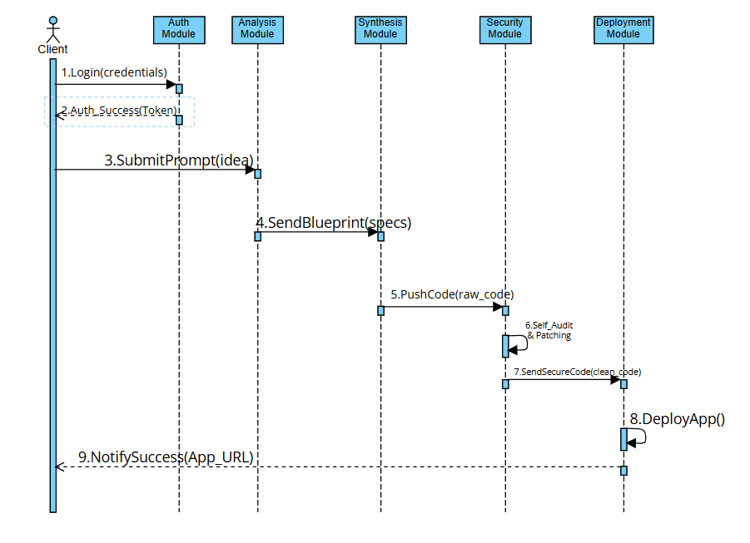
  - Sequence Diagram User Authentication Details
This diagram provides a low-level technical view of the User Authentication process. It details the communication between the Actor (User), the Auth Interface, the Auth Controller, and the User Database. It captures the exact steps required to verify a user's identity before they can access the NEX0S A1 dashboard
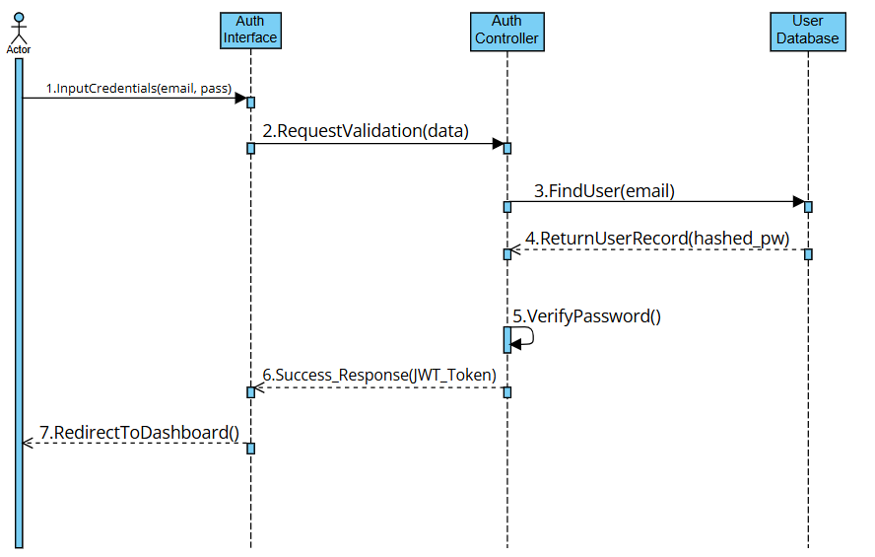
  - Sequence Diagram Requirement Analysis Phase
This diagram visualizes the internal logic of the Analysis Engine AI as it processes the user's input. It shows the detailed message exchange between the AI Brain, the Analysis Engine, the Tech-Stack Database, and the Logic Auditor to ensure the project requirements are technically sound
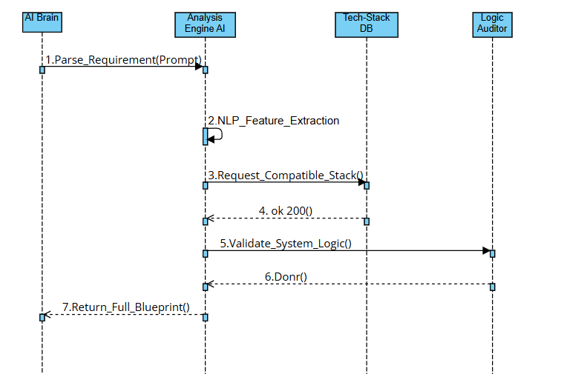
  - Sequence Diagram Full-Stack Synthesis Phase
This diagram illustrates the coordinated effort between specialized AI engines during the code generation phase. It tracks the flow of messages between the AI Brain, Frontend Engine, Backend Engine, and DB Generator to build a unified software package
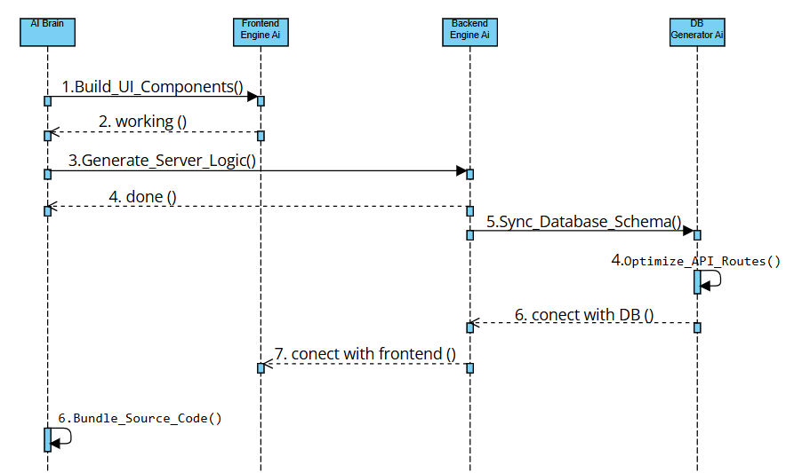
  - Sequence Diagram Security Hardening Phase
This diagram visualizes the automated security pipeline triggered by the AI Brain. It illustrates the interaction between the SAST Scanner, the Vulnerability Database, and the Patching Engine to identify and neutralize code-level threats
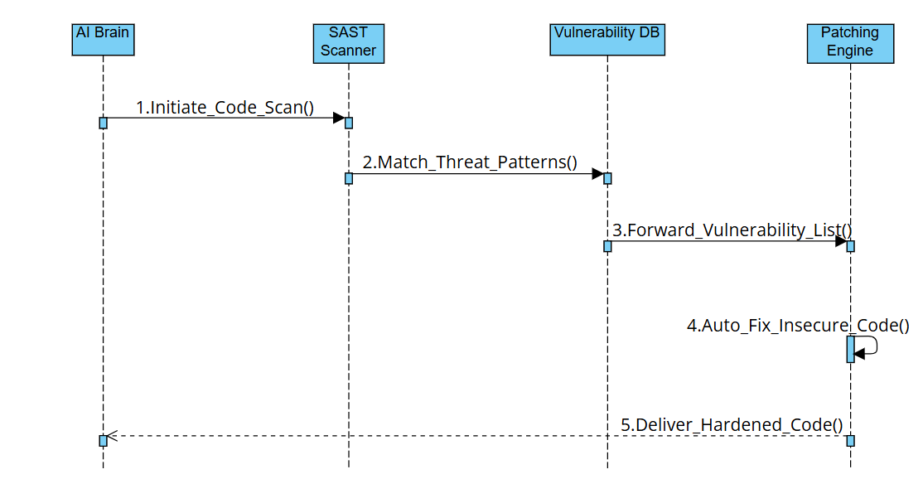
  - Sequence Diagram Autonomous Deployment Phase
This diagram illustrates the final synchronization between the AI Brain, Cloud Infrastructure, and Config Manager. It details the automated steps required to transition the hardened code into a live, accessible web application for the Client
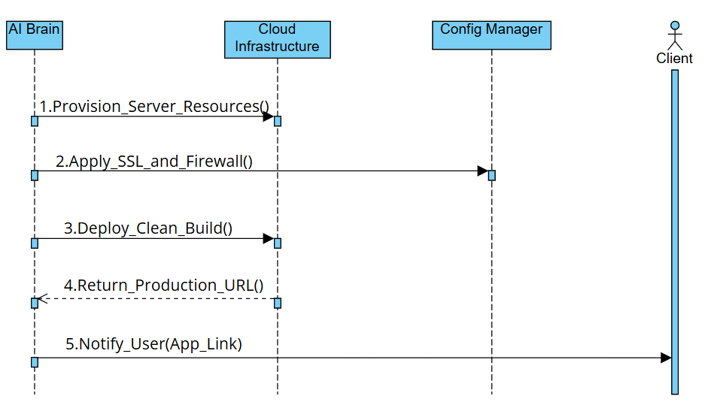

  - Activity Diagram
This diagram provides a step-by-step visualization of the NEX0S A1 operational workflow. It maps the dynamic behavior of the system, starting from the user's initial Login and following the logical path through analysis, code synthesis, and the iterative security loop
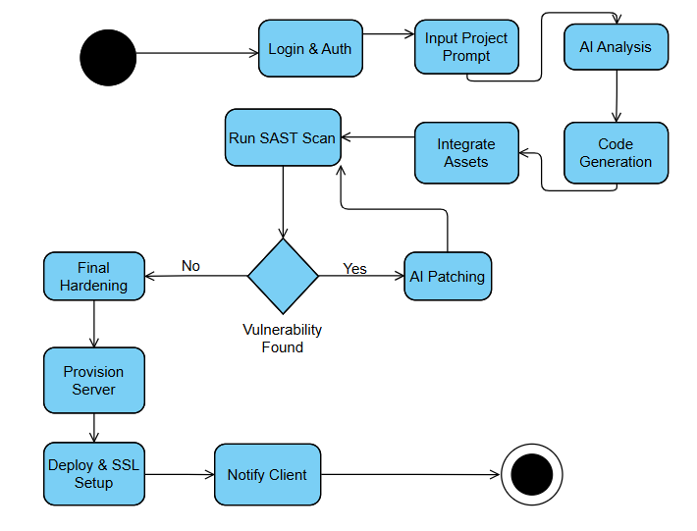
  - Class Diagram
This diagram represents the static structure of the NEX0S A1 system by showing its classes, attributes, operations, and the relationships between objects. It defines the blueprint of the system's codebase, illustrating how entities like User, Project, AIBuilder, and SecurityModule are structured and how they communicate with each other
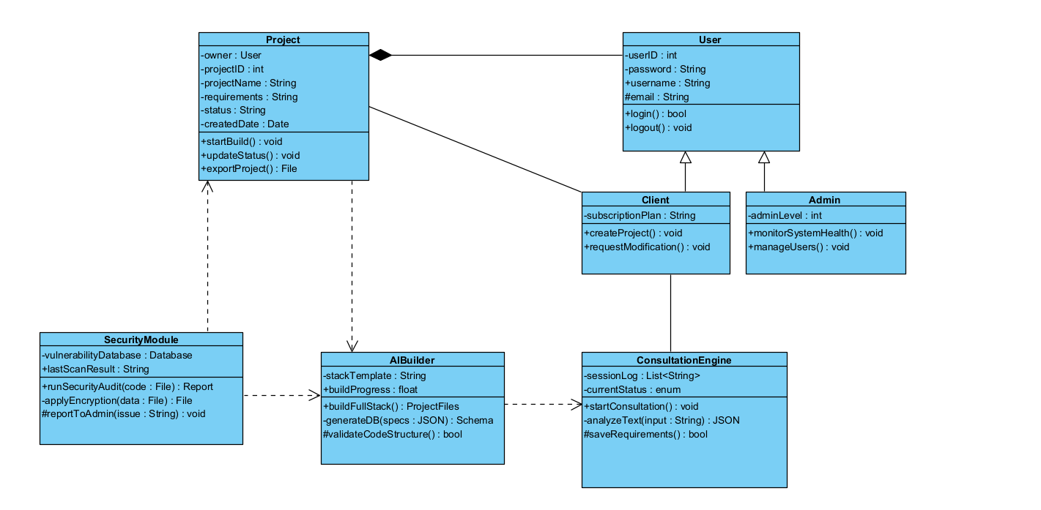
  - DFD Diagrams Level 0
This diagram provides a detailed overview of the information flow within the NEX0S A1 system. It identifies the major processes, external entities (User and Cloud Provider), and the data stores (User Database, Project Requirements, and Secure Artifacts Repo) that manage the system's state
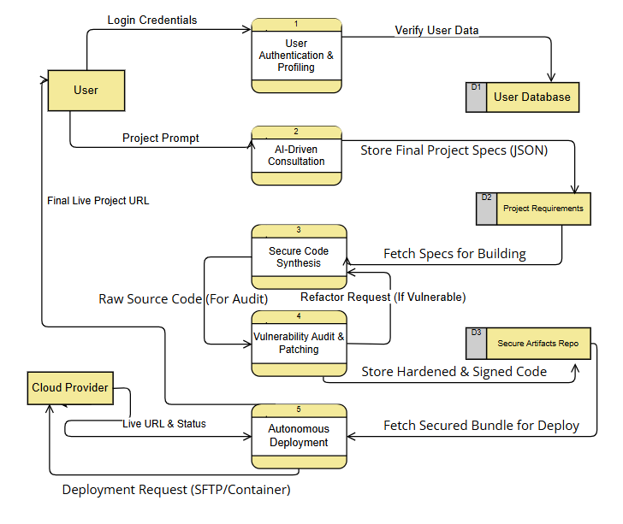
  - DFD Diagrams Level 1
This diagram provides a decomposed view of the User Profiling process from Level 0. It breaks down the authentication flow into three specific sub-processes: Verify Credentials, Authorize Permissions, and Manage Session, illustrating a granular look at how user security is handled
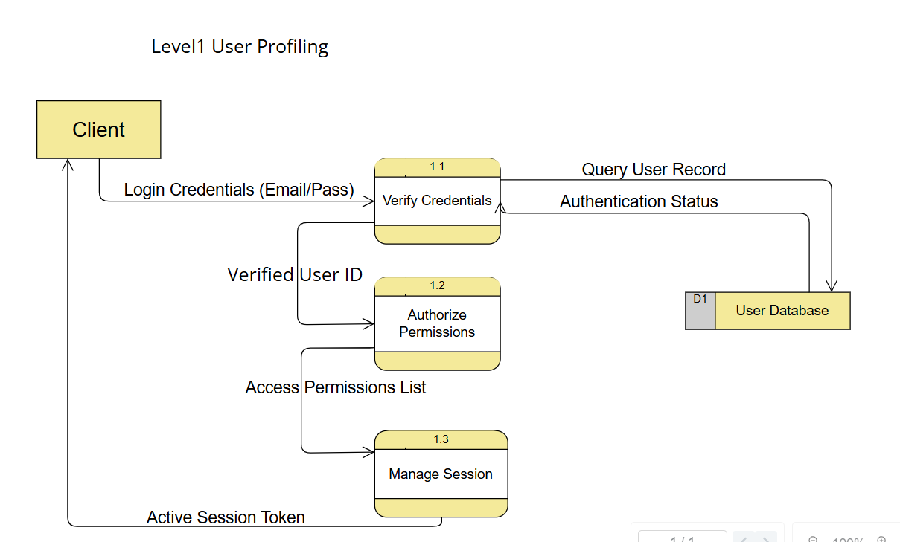
  - DFD Diagrams Level 2
This diagram provides a deep-dive (Level 2) into the AI-Driven Consultation process. It breaks down how the system handles the user's natural language input, showing the internal flow between three specialized sub-processes: NLP Parsing, Logic Extraction, and Blueprint Synthesis
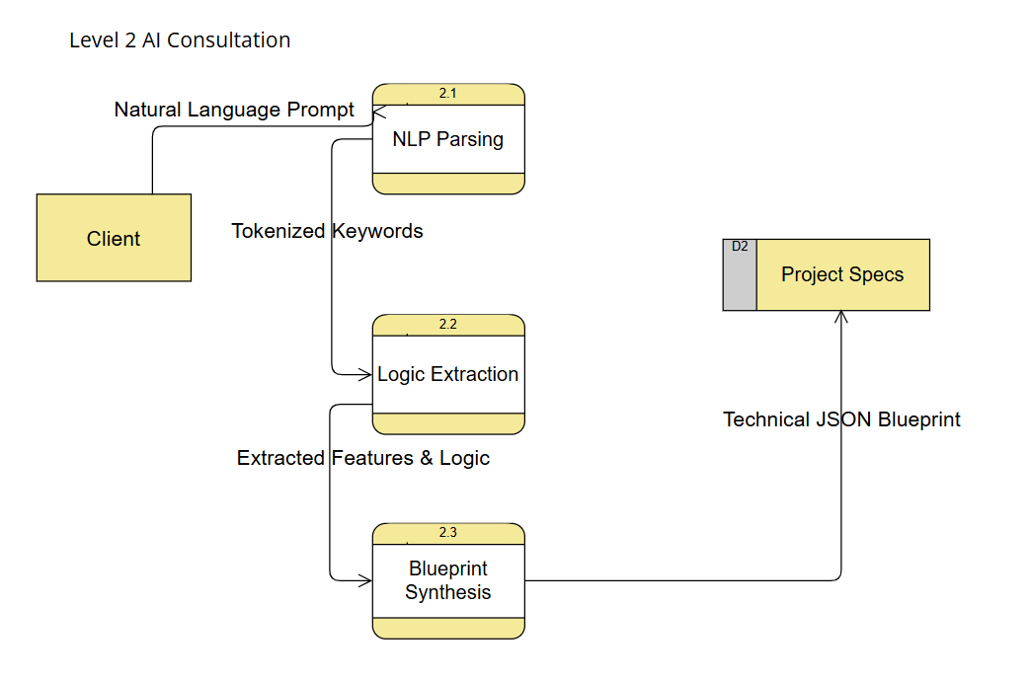
  - DFD Diagrams Level 3
This diagram presents a high-resolution view (Level 3) of the Full-Stack Code Synthesis process. It details the internal data orchestration between four specialized sub-units: Frontend Architect, Backend Coder, DB Schema Builder, and the Asset Integrator
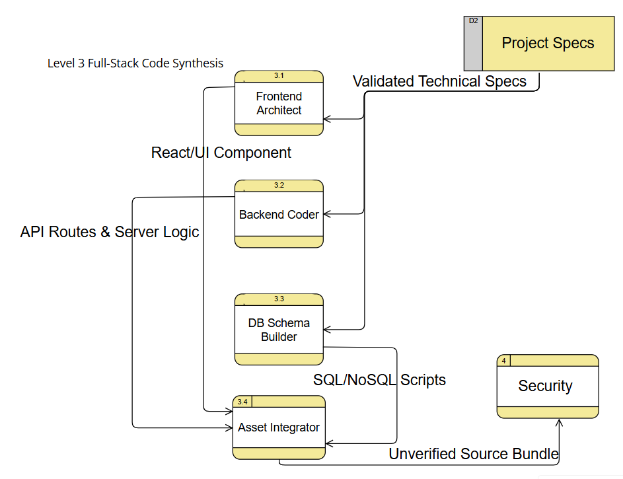
  - DFD Diagrams Level 4
This diagram provides a high-resolution functional decomposition (Level 4) of the Security Audit & Patching phase. It visualizes the internal data flow between four specialized security sub-processes: SAST Scanner, Vulnerability Analyzer, AI Patching Engine, and Code Signing
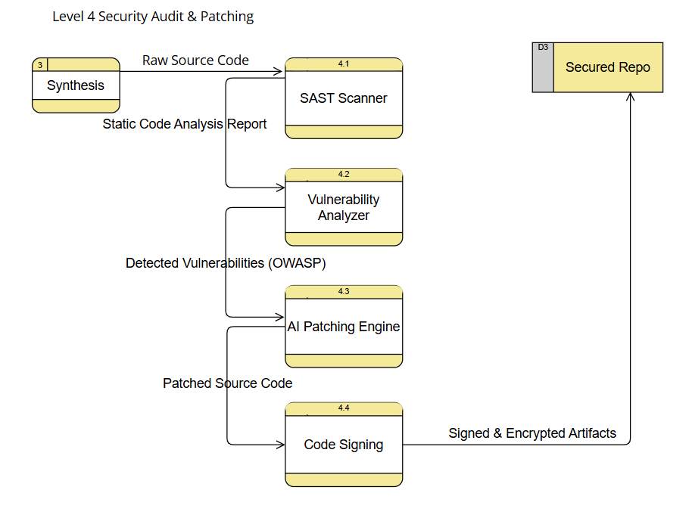
  - DFD Diagrams Level 5
This diagram provides a high-resolution functional decomposition (Level 5) of the Autonomous Deployment phase. It maps the data movement between the Secured Repo (D3), the internal deployment sub-processes (Asset Bundler, Cloud Provisioner, and SSL & DNS Manager), and the external Cloud Provider.
